# **L****ogical Model**

*Package in package 'MySQL'*

Logical Model

Version 1.0 Phase 1.0 Proposed

EA created on 7/6/2023. Last modified 7/6/2023

## **Logical Model diagram**

*Data Modeling diagram in package 'Logical Model'*

Logical Model

Version 1.0

Dannyel created on 7/6/2023. Last modified 7/6/2023

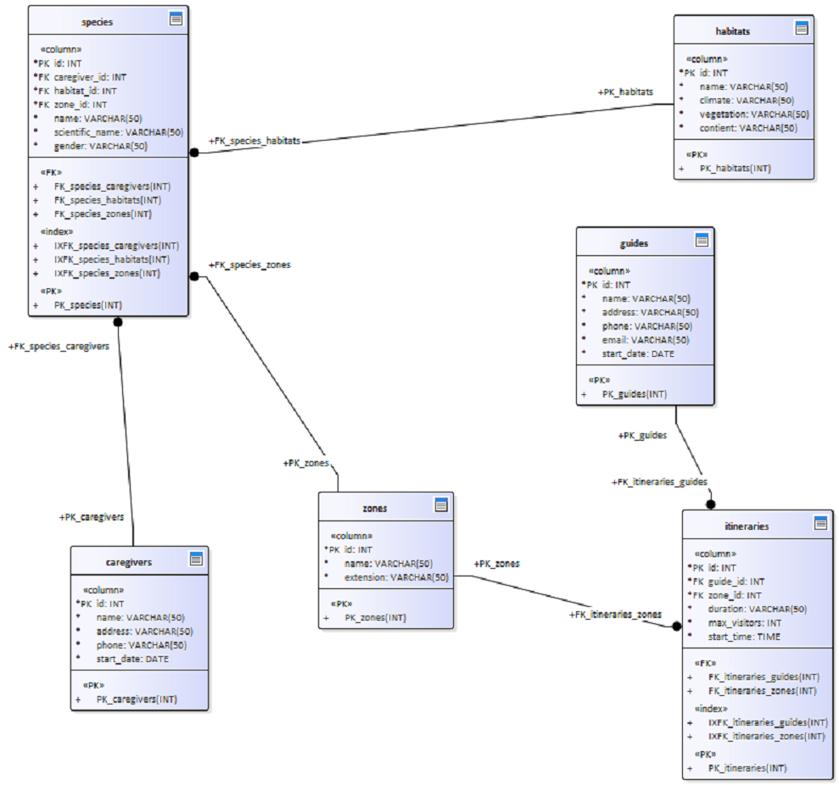

Logical Model

## **caregivers**

*Database table in package 'Logical Model'*

caregivers

Version 1.0 Phase 1.0 Proposed

Dannyel created on 7/6/2023. Last modified 7/6/2023

DBMS MySql

| **COLUMN NAME** | **DATATYPE** | **NOT NULL** | **COMMENTS** |
| --- | --- | --- | --- |
| id | INT | True | Properties:  AutoNum = True  property = AutoNum=True; |

|  |  |  |  |
| --- | --- | --- | --- |
| name | VARCHAR(50) | True |  |

|  |  |  |  |
| --- | --- | --- | --- |
| address | VARCHAR(50) | True |  |

|  |  |  |  |
| --- | --- | --- | --- |
| phone | VARCHAR(50) | True |  |

|  |  |  |  |
| --- | --- | --- | --- |
| start_date | DATE | True |  |

|  |  |  |
| --- | --- | --- |
| **PRIMARY KEY NAME** | **COLUMNS** | **COMMENTS** |
| PK_caregivers | id |  |

## **guides**

*Database table in package 'Logical Model'*

guides

Version 1.0 Phase 1.0 Proposed

Dannyel created on 7/6/2023. Last modified 7/6/2023

DBMS MySql

| **COLUMN NAME** | **DATATYPE** | **NOT NULL** | **COMMENTS** |
| --- | --- | --- | --- |
| id | INT | True | Properties:  AutoNum = True  property = AutoNum=True; |

|  |  |  |  |
| --- | --- | --- | --- |
| name | VARCHAR(50) | True |  |

|  |  |  |  |
| --- | --- | --- | --- |
| address | VARCHAR(50) | True |  |

|  |  |  |  |
| --- | --- | --- | --- |
| phone | VARCHAR(50) | True |  |

|  |  |  |  |
| --- | --- | --- | --- |
| email | VARCHAR(50) | True |  |

|  |  |  |  |
| --- | --- | --- | --- |
| start_date | DATE | True |  |

|  |  |  |
| --- | --- | --- |
| **PRIMARY KEY NAME** | **COLUMNS** | **COMMENTS** |
| PK_guides | id |  |

## **habitats**

*Database table in package 'Logical Model'*

habitats

Version 1.0 Phase 1.0 Proposed

Dannyel created on 7/6/2023. Last modified 7/6/2023

DBMS MySql

| **COLUMN NAME** | **DATATYPE** | **NOT NULL** | **COMMENTS** |
| --- | --- | --- | --- |
| id | INT | True | Properties:  AutoNum = True  property = AutoNum=True; |

|  |  |  |  |
| --- | --- | --- | --- |
| name | VARCHAR(50) | True |  |

|  |  |  |  |
| --- | --- | --- | --- |
| climate | VARCHAR(50) | True |  |

|  |  |  |  |
| --- | --- | --- | --- |
| vegetation | VARCHAR(50) | True |  |

|  |  |  |  |
| --- | --- | --- | --- |
| contient | VARCHAR(50) | True |  |

|  |  |  |
| --- | --- | --- |
| **PRIMARY KEY NAME** | **COLUMNS** | **COMMENTS** |
| PK_habitats | id |  |

## **itineraries**

*Database table in package 'Logical Model'*

itineraries

Version 1.0 Phase 1.0 Proposed

Dannyel created on 7/6/2023. Last modified 7/6/2023

DBMS MySql

| **COLUMN NAME** | **DATATYPE** | **NOT NULL** | **COMMENTS** |
| --- | --- | --- | --- |
| id | INT | True | Properties:  AutoNum = True  property = AutoNum=True; |

|  |  |  |  |
| --- | --- | --- | --- |
| guide_id | INT | True |  |

|  |  |  |  |
| --- | --- | --- | --- |
| zone_id | INT | True |  |

|  |  |  |  |
| --- | --- | --- | --- |
| duration | VARCHAR(50) | True |  |

|  |  |  |  |
| --- | --- | --- | --- |
| max_visitors | INT | True |  |

|  |  |  |  |
| --- | --- | --- | --- |
| start_time | TIME | True |  |

|  |  |  |
| --- | --- | --- |
| **PRIMARY KEY NAME** | **COLUMNS** | **COMMENTS** |
| PK_itineraries | id |  |

|  |  |  |
| --- | --- | --- |
| **TYPE / NAME** | **COLUMNS** | **COMMENTS** |
| «index» IXFK_itineraries_guides | guide_id |  |

|  |  |  |
| --- | --- | --- |
| «index» IXFK_itineraries_zones | zone_id |  |

|  |  |  |
| --- | --- | --- |
| **FOREIGN KEY NAME** | **COLUMNS** | **REFERENCES** |
| FK_itineraries_zones | zone_id | zones(id) |

|  |  |  |
| --- | --- | --- |
| FK_itineraries_guides | guide_id | guides(id) |

## **species**

*Database table in package 'Logical Model'*

species

Version 1.0 Phase 1.0 Proposed

Dannyel created on 7/6/2023. Last modified 7/6/2023

DBMS MySql

| **COLUMN NAME** | **DATATYPE** | **NOT NULL** | **COMMENTS** |
| --- | --- | --- | --- |
| id | INT | True | Properties:  AutoNum = True  property = AutoNum=True; |

|  |  |  |  |
| --- | --- | --- | --- |
| caregiver_id | INT | True |  |

|  |  |  |  |
| --- | --- | --- | --- |
| habitat_id | INT | True |  |

|  |  |  |  |
| --- | --- | --- | --- |
| zone_id | INT | True | Properties:  AutoNum = True  property = AutoNum=True; |

|  |  |  |  |
| --- | --- | --- | --- |
| name | VARCHAR(50) | True |  |

|  |  |  |  |
| --- | --- | --- | --- |
| scientific_name | VARCHAR(50) | True |  |

|  |  |  |  |
| --- | --- | --- | --- |
| gender | VARCHAR(50) | True |  |

|  |  |  |
| --- | --- | --- |
| **PRIMARY KEY NAME** | **COLUMNS** | **COMMENTS** |
| PK_species | id |  |

|  |  |  |
| --- | --- | --- |
| **TYPE / NAME** | **COLUMNS** | **COMMENTS** |
| «index» IXFK_species_caregivers | caregiver_id |  |

|  |  |  |
| --- | --- | --- |
| «index» IXFK_species_habitats | habitat_id |  |

|  |  |  |
| --- | --- | --- |
| «index» IXFK_species_zones | zone_id |  |

|  |  |  |
| --- | --- | --- |
| **FOREIGN KEY NAME** | **COLUMNS** | **REFERENCES** |
| FK_species_caregivers | caregiver_id | caregivers(id) |

|  |  |  |
| --- | --- | --- |
| FK_species_habitats | habitat_id | habitats(id) |

|  |  |  |
| --- | --- | --- |
| FK_species_zones | zone_id | zones(id) |

## **zones**

*Database table in package 'Logical Model'*

zones

Version 1.0 Phase 1.0 Proposed

Dannyel created on 7/6/2023. Last modified 7/6/2023

DBMS MySql

| **COLUMN NAME** | **DATATYPE** | **NOT NULL** | **COMMENTS** |
| --- | --- | --- | --- |
| id | INT | True | Properties:  AutoNum = True  property = AutoNum=True; |

|  |  |  |  |
| --- | --- | --- | --- |
| name | VARCHAR(50) | True |  |

|  |  |  |  |
| --- | --- | --- | --- |
| extension | VARCHAR(50) | True |  |

|  |  |  |
| --- | --- | --- |
| **PRIMARY KEY NAME** | **COLUMNS** | **COMMENTS** |
| PK_zones | id |  |